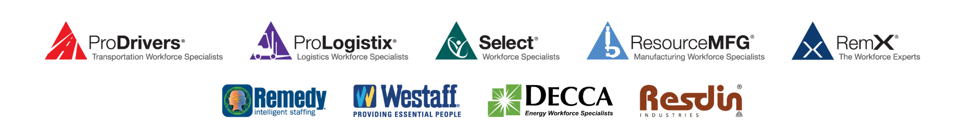

EmployBridge COVID-19 Coronavirus Client Update

Nothing is more important than safety. In these uncertain times, we’re taking extra steps to
protect the health and well-being of our people and partners—and ensure the safe operation
of our clients’ businesses and our own.

Keeping You Informed Regarding Our Response to the COVID-19 Coronavirus

Now, more than ever, we are committed to doing everything possible to protect the health and well-being of your employees, as well as our own, and to minimize any potential disruptions to your business.

Our business continuity and life safety teams have been closely monitoring updates from the Centers for Disease Control and Prevention (CDC). In response to the growing spread of the COVID-19 coronavirus, we have implemented the following policies and procedures, in alignment with guidance from the CDC, to help contain the spread of the virus:

- We have instructed all our associates and employees that they must follow the CDC’s guidance regarding frequent handwashing with soap and water for the appropriate duration (20 second rule) or the use of hand sanitizer. We are currently in the process of deep cleaning all branches and on-site locations.

- Any of our associates or employees who disclose that they have recently traveled out of the country or have been on a cruise are being instructed not to come to work until 14 days after their return to the United States. The same applies if an associate or employee discloses that they have been in close contact with someone who has recently traveled outside the country. This applies even if they are symptom-free.

- If any associate reports that they have any symptoms that could indicate infection with coronavirus, such as fever, cough, or respiratory distress, they will be told not to return until 72 hours have passed with no symptoms.

- If an associate or employee tests positive for coronavirus or is diagnosed with coronavirus by a doctor (with or without a positive test confirmation), we require that they provide a doctor’s note clearing him/her to return to work, but in no event less than 14 days from diagnosis.

Keeping You Informed Regarding Our Response to the COVID-19 Coronavirus

- If an associate tests positive for coronavirus and has been working in your facility, we will notify you immediately so that you can take appropriate corrective measures.

- We are advising our associates and employees to not report to work if they have a fever of 100 degrees or more.

- We are implementing a temperature check procedure and will not allow anyone to enter our branches who has a temperature of 100 degrees or more.

- We recognize you may have an attendance policy that does not support the preceding two changes. In the interest of the health and safety of our employees and yours, we hope you will allow this change temporarily.

We will continue to modify our procedures as needed in response to this evolving situation and will communicate these to you at the appropriate time. In the meantime, if you have any questions, please do not hesitate to contact your business development manager or primary contact with our company.

Also, if you want to keep up to date with the actions and recommendations of the CDC, the best sources are its websites at https://www.cdc.gov/coronavirus/2019-ncov/index.html or in Spanish at https://www.cdc.gov/coronavirus/2019-ncov/index-sp.html.
V 0.3 032420

