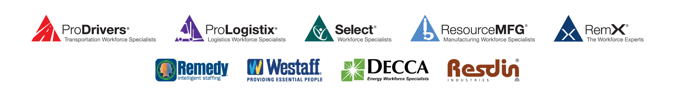

EmployBridge COVID-19 Coronavirus Associate Update

Nothing is more important than your safety. In these uncertain times,
we’re taking extra steps to protect your health and well-being.

Keeping You Informed Regarding Our Response to the COVID-19 Coronavirus

You are no doubt aware of the evolving situation with the COVID-19 coronavirus around the world. We have been watching the situation very closely, and we want you to know that we take the risks associated with the coronavirus very seriously. As of right now, our emphasis is on doing what we can to help reduce the risk of contracting or spreading the virus.

The Centers for Disease Control and Prevention (CDC) is the best source for information about the coronavirus. We use its resources as our primary source of information about this virus. If you want to keep up with the latest news from the CDC, you can visit their website at https://www.cdc.gov/coronavirus/2019-ncov/index.html or in Spanish at https://www.cdc.gov/coronavirus/2019-ncov/index-sp.html.

We ask the following of you:

- Per the CDC’s guidance, we are continuing to advise you not to come to work if you have a temperature of 100 degrees or higher. We are coordinating with our clients on any other specific procedures they may ask us to follow. If the client you are working for has stricter rules about the coronavirus, please follow them. If you have questions or concerns about those rules or think they are unreasonable, contact your branch or staff performance manager.

- Wash your hands frequently using the “20-second rule.” Fact: soap and water are very effective at controlling disease spread, and according to the CDC, it does not matter whether the water is hot or cold. The CDC even has training videos. If you would like to learn more, just go to https://www.cdc.gov/handwashing/.
- Use alcohol-based hand sanitizer frequently when soap and water are not readily available.

- Cover your mouth if you are going to cough or sneeze. Please use a tissue, then discard the tissue and wash your hands.

- Avoid touching your face. This is one way that contagious diseases enter your system.

- Avoid physical contact with others (for example, avoid shaking hands with others). This will reduce chances of transmission.

- If you have traveled outside the country or returned from a cruise in the past two weeks, you should not come to work until 14 days have passed since your return to the United States. Likewise, if you have been in close contact with someone who has been out of the country in the last fourteen days, please notify your manager. In this case, you will be asked to take off work for fourteen days from your last contact with that person.

If you have any questions, call your branch. If the representatives do not know the answer, they will find it for you.
V 0.3 032420

